Working Solution

Last update：2020-5-15

version：V1.0

author：Dean Peng

**1、System environment**

**1.1 JDK1.8**

**1.2 mavn(complie stage)**

**2、Solution Structure**

**2.1 technology used**

Frontend ：jqGrid, vue

Backend ：springboot, freemarker

Persistent layer：use Microsoft Excel

**2.2 solution struture**

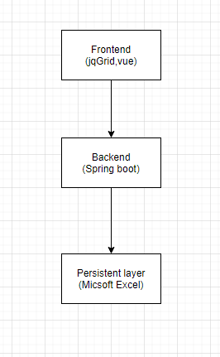

**3、Demonstration**

**2.1 check out source code from github, repository address(**[**https://github.com/DeanPL/PositionManagement.git**](https://github.com/DeanPL/PositionManagement.git) **)**

**2.2 go to project root folder，use maven compile the project**

**2.3 import project into eclipse or idea**

**2.4 start application from main class com.infosys.demo. App.java**

**2.5 browser open** <http://localhost:8080/PM/index.html>